NH PFML Paycheck Mailer – 100% Employer Sponsored

New Benefit Announcement

*Coming Soon*

**New Hampshire Paid Family and Medical Leave (NH PFML)**

As an employee of [company], you have been enrolled in a NH PFML insurance plan providing you with a 60% wage replacement insurance benefit (up to the Social Security wage cap) for common life events that may take you away from work.

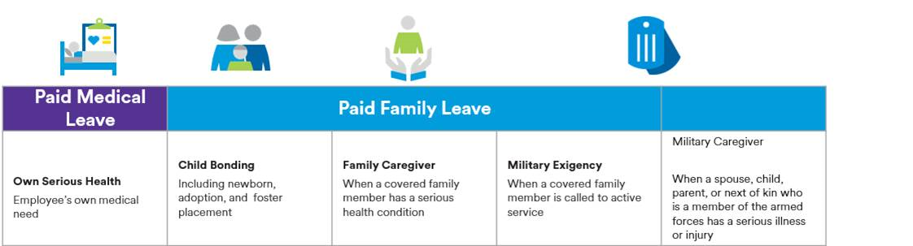

To learn more about your NH PFML Plan sponsored by [employer], talk to [employer contact].

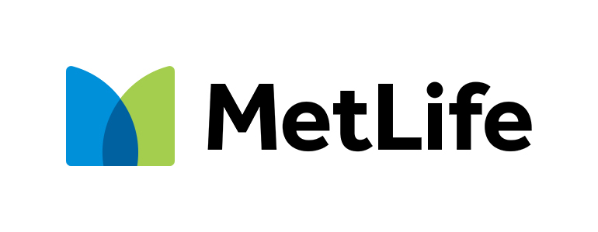

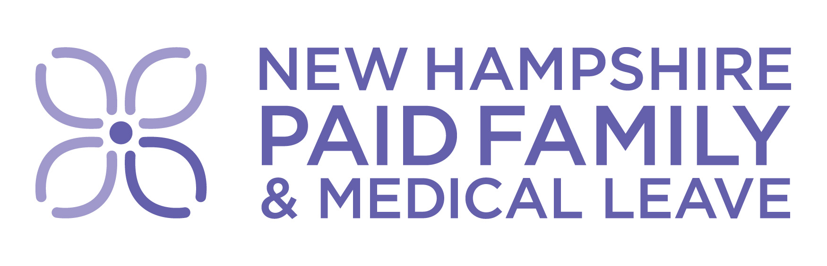

Add QR code NH PFML

Learn more about   
NH Paid Family and Medical Leave

[PaidFamilyMedicalLeave.nh.gov](https://nhgov-my.sharepoint.com/personal/laura_r_holmes_das_nh_gov/Documents/A_DAS/A_PROJECTS/PFML/WORK%20STREAMS/Other%20Employers%20and%20Individuals/Paycheck%20mailer/PaidFamilyMedicalLeave.nh.gov)



NH PFML Paycheck Mailer –Employer/Employee shared





Add QR code NH PFML

Learn more about   
NH Paid Family and Medical Leave

[PaidFamilyMedicalLeave.nh.gov](https://nhgov-my.sharepoint.com/personal/laura_r_holmes_das_nh_gov/Documents/A_DAS/A_PROJECTS/PFML/WORK%20STREAMS/Other%20Employers%20and%20Individuals/Paycheck%20mailer/PaidFamilyMedicalLeave.nh.gov)



New Benefit Announcement

*Coming Soon*

**New Hampshire Paid Family and Medical Leave Insurance**

As an employee of [company], you are eligible to enroll in NH Paid Family and Medical Leave insurance plan providing you with a 60% wage replacement insurance benefit (up to the Social Security wage cap) for common life events that may take you away from work.

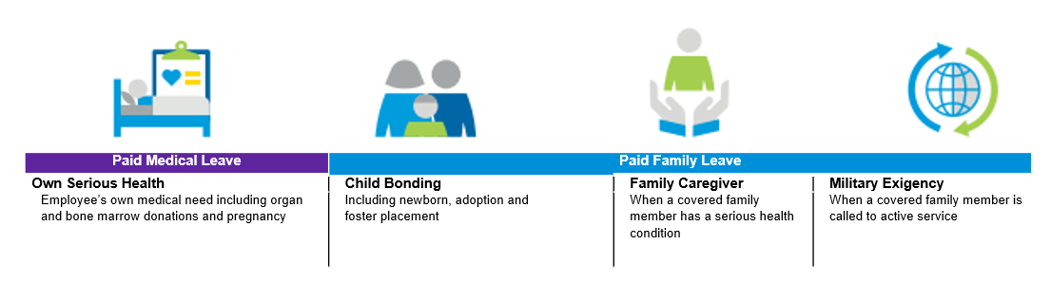

To learn more about the NH PFML Plan made available through [employer], talk to [employer contact] [about coverage and any financial obligations].